# Apparel Showroom - Layout

# Factory Layout

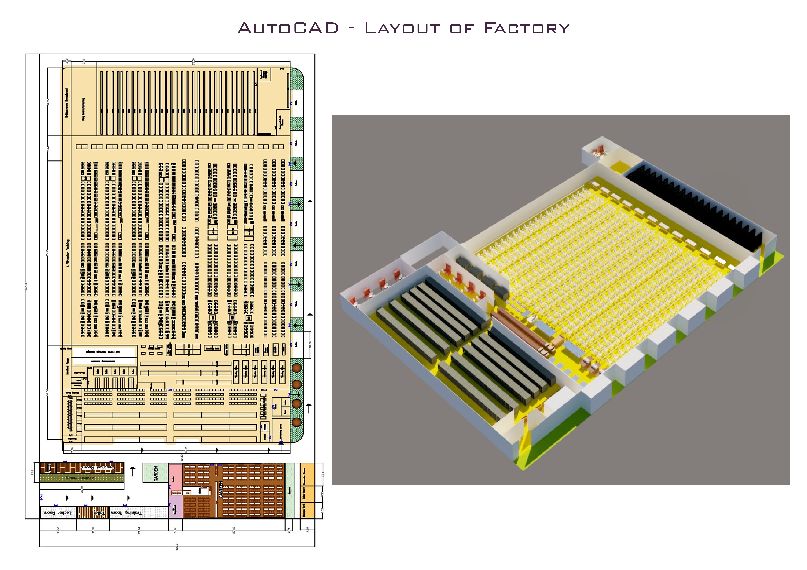

# Orthographic View of Single Needle Lock Stitch Machine

# Orthographic View of CPU

# 

# Orthographic View of Laptop

# 

# 3D Model of a House

